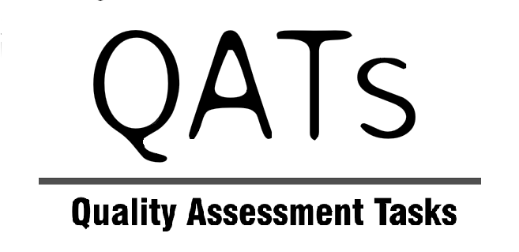

2008 YEAR 12 MID-YEAR EXAMINATION – CHEMISTRY

IMPORTANT NOTICE ABOUT THIS EXAM

- Two Chemistry Mid-year exam papers are available:
- 16.1 MIDCHEM08A – Core only (1 hour 30 minutes)
- 16.2 MIDCHEM08B – Core plus option: Shipwrecks, Corrosion and Conservation (2 hours 25 minutes)

- You can customise these exam papers by editing the Word documents to remove questions as required. Teachers have the opportunity to select or delete questions according to their preference.

- IMPORTANTLY, when editing these papers, please note that questions and page numbers need to be renumbered, any variation to allocation of marks and time throughout the papers needs to be monitored carefully AND the resulting ‘working time’ needs to be advised in the ‘General Instructions’ section.

- In customising these papers you can also include your school logo. In editing these exam papers please take every precaution as indicated in the publisher’s disclaimer.

